Smart Traffic Monitoring System based on vehicle counts.

**group 04**

**- au820421106031 |**

**Mukilan**

**| Phase 01**

*The traffic Management system is the keystone of a smart city.*

*If the number of vehicles that are to be passed through a crowded junction can be pre-estimated in time, traffic*

*blockage can be managed effectively. In this paper, a method is demonstrated to control the traffic signals based on the count*

*of automobiles and pedestrians. The data from both these systems are given to the Node MCU board. The proposed method presents a framework, which will optimize the timing interval of the traffic signal purely depending on the number of vehicles on that particular roadside. The number of vehicles passing through an area well before the preferred traffic junction can be estimated using the help of image processing techniques. Further, the monitoring information can be shared to a distant controlling center situated anywhere in the city via internet usage. The decrease in waiting time for drivers to cross signal will be the major advantage of this proposed system. In this model, we are using OpenCV for image*

*processing and vehicle detection. The input of these systems is vehicles counts on each side of the road from the crossing signal and this input will be determined by how much time is*

*to be provided.*

**:** Traffic Management System (TMS), Open CV, Node MCU, Image Processing, Vehicle Detection.

***Key Words***

# INTRODUCTION

Traffic Congestion is an excessive and conspicuous hassle, properly controlled via the use of website online traffic alerts, and a dependable way to perform intersections inside the everyday website visitors worldwide. numerous breathing troubles such as bronchial asthma and bronchitis due to exposure to avenue dust and automobile emissions. in addition, traffic police and pedestrians are at multiplied risk of lung maximum cancers because of publicity to air pollutants that WHO has classified as carcinogenic.

Many troubles arise due to the normal individual timer.

They

trheepeat the identical segment series and no longer use shopping for and promoting duration. similarly, the

long-

prepared time of the car in the usage of mode ends in inefficient gas consumption and multiplied

environmental pollution.

India is many of the 10 countries with the maximum

web

page traffic congestion. Mumbai, Bangalore, New Delhi.

human beings are under pressure to spend hours with site visitors and waste valuable time commuting. cutting- edge web page traffic mild controllers use tough, speedy timers and do not adapt to real-time site visitors on the road. to alleviate traffic congestion, we have a**4**dvanced an advanced traveler management tool that could autonomously adapt to the vacationer's scenario on Traffic symptoms within the shape of a computer imaginative and prescient-primarily based traffic mild controller.

## Existing System:

In India the existing traffic system is for each red signal 60

speacrtoicnudlasrwill be given, whether the traffic on that

road is heavy or light, with this the wastage of time will

be

high and traffic in other lanes will be increasing.

## Proposed System:

The main objective of the project is to design a traffic light

tsryasfftiecm based on the vehicle counts in that current situation. Here the proposed system takes the live

streaming

afrnodm public surveillance cameras at traffic junctions detecting the vehicles at the signal sets the green signal

time.

Here vehicles will be classified such as cars, bikes,

buses/trucks, and rickshaws to obtain a more accurate estimate of the green signal time.

Our proposed system will pass the live streaming from tphueblic surveillance cameras from the traffic junctions. In

cloud, the algorithm will process the live cam feed and

every

tfhraeme from the live is processed and will go through Open CV filters and detects the contours and movements

of

aonbdjects on the lane (road) in the feed and considers distinguishes it as vehicles, animals and human beings

which

daerefintaekden into account and density of the traffic is and the magnitude of the instantaneous density and mincarneamgenr t in density is sent to the on-board vehicle and vehicles traffic management algorithm will decide

which tlaimne traffic light will glow first and for how much of the will be needed to that particular lane and update the

red

signal times of the other signals.

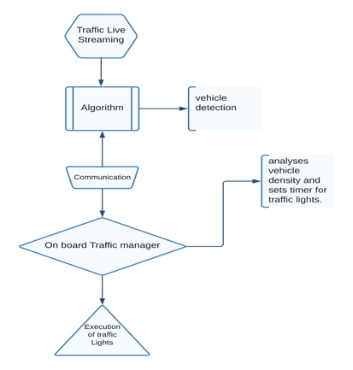

**d Te2. IMPLEMENTATION** Example:

1st lane = 30 Vehicle Counts 2nd lane = 40 Vehicle Counts 3rd lane = 60 Vehicle Counts

so, the time divided is to the lanes is like

Green light time for 1st lane = [30/ (30+40+60)] *120 sec Green light time for 2nd lane = [40/ (30+40+60)] *120 sec Green light time for 3rd lane = [60/ (30+40+60)] *120 sec

## Fig .1. Proposed Traffic model system

Traffic Management System is to get the vehicle counts in real-time by using Open CV algorithms in the cloud here we are detecting the moving objects in the live cam using

background subtraction algorithms like MOG, MOG2, GMG

In our criteria we used MOG to easily detect the movements

and to get rid of shadow and noise we used gaussian blur and also converted the video frames one by one to greyscale and then passed through the Image subtraction MOG algorithm so the upper layer of the frames has been detected and then the algorithm will mark it with rectangle frame for every moving objects so an if loop will count the number of rectangles by adding a dot in the rectangle and then we have created a virtual line in the frame so the number of dots which will cross the line is the count of vehicles.

For now, the cloud image processing is done. From here we

have to transfer the number of vehicles in every lanes data to the on-board traffic managing unit which is an IoT-based microcontroller Node MCU the transfer of data is done by TCP /Ip using python URL and HTTPS libraries here the IP address of the Node MCU of every lane is provided to the cloud in a table or a datagram so that the data is sent to the respective on-board traffic management units.

The on-board unit which is Node MCU will calculate the time

to be allocated to every lane traffic signal according to the density by dividing the 2-minute time frame to every lane according to the percentage of density on the respective lanes.

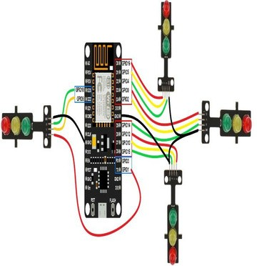

## Fig.2. Node MCU Interfacing

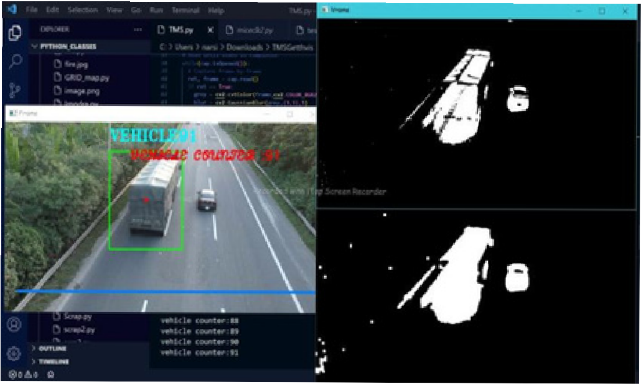

**Fig .2. Real-time operation**.

protected on this.

accident or breakdown detection: Intersections also tend to

revel in intense crashes because numerous sorts of injurious crashes, consisting of attitude and left-flip collisions, commonly occur there. consequently, accurate and activated detection of injuries at intersections gives remarkable blessings of saving houses and lives and minimizing congestion and delay. this will be achieved with the aid of figuring out the vehicles that remain desk-bound for a long term in an inappropriate function together with within the middle of the street, so that parked automobiles are not

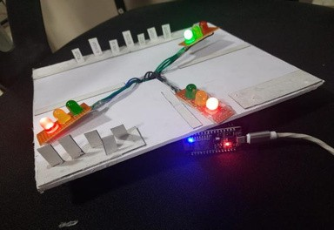

**Fig .2. Traffic light signal in a working process**. Synchronization of site traffic signals throughout more than

one intersection. Synchronizing indicators along a street can

1. **CONCLUSIONS** gain the commuters as soon as a vehicle enters the road, it

can continue with minimal prevention.

Adapting to emergency motors: Emergency cars such as an

ambulance want to accept faster passage through the traffic indicators. The model can be educated to hit upon no longer just cars but additionally be able to recognize that it is an

We are successful in classifying humans, vehicles, andemergency vehicle and hence adapt the timers such that the

animals as precisely as possible. Detection of these mergency vehicle is given priority and may cross the sign at thoebjeacrtlsiewsti.ll vary according to the weather conditions as

well as day and night duration, we are trying to improve

our system for every weather and lighting condition as the whole system depends upon the quality of video captured by the cameras like exposure, saturation, hue and color temperature. Our algorithm divides the traffic light timing efficiently sent as possible. So, our whole

traffic management system works nearly 96% efficiently when compared to present working traffic management

# REFERENCES

systems. [1] A. Kanungo, and A. Sharma in the year 2014,

# FUTURE SCOPE:

Because of the non-stop increase of the population inside the global, it is an extraordinary challenge for the imminent generation to manipulate the Traffic system. a good deal of improvement will come in the future. To manipulate the conventional transport device, we must consider an intelligent and automated manner of controlling the machine. as the population increases, it will increase the range of motors also. to manipulate the huge wide variety of vehicles intelligent methods ought to be followed. For future purposes, we can use the picture sensor or imager. It does its work by generating photos of the roads. It creates the image with the aid of changing the variable attenuation of mild into a sign that conveys the photograph.

The venture can be further increased to consist of the afonlldowing functionalities to enhance traffic management convey down congestion:

Identity of automobiles violating traffic regulations: The

motors going for walks purple lighting fixtures can be diagnosed in a photograph or a video move using

defining a ovifolation line and taking pictures the wide variety plate the photo if that line is crossed when the sign is pink.

Lane bcheanging can also be recognized in addition. these may

proposed a solution using video processing. The video from the live feed is processed before being sent to the servers where a C++- based algorithm is used to generate the results. Hard code and Dynamic coded methodologies are compared, in which the dynamic algorithm showed an improvement of 35%.

1. Sakuna Prontri, and Pongpisit Wuttidittachotti, in the tyheaatr 2015, proposed a fuzzy logic-controlled traffic light

can be adapted to the current traffic situations. This

system omnaekes use of two fuzzy controllers with 3 inputs and output for primary and secondary driveways. A

simulation

twrafsficdone using VISSIM and MATLAB and for low density, it improved traffic conditions.

1. Siddharth Srivastava, and Raj Kamal in the year

2016,

ipmroapgoesed the use of adaptive light timer control using processing techniques and traffic density. This system consists of a microcontroller-controlled traffic light timer, high image sensing devices, MATLAB, and transmission using UART principles. However, this system fails to prioritize the authorized emergency vehicles nor to

detect

accidents at the intersection.